mCarTest Android Application
Software Requirement Specifications

Version 1.0

Class Name | Lập trình di động
Class Code | MMT03
Group
Teacher | Nguyễn Anh Tuấn
Project Manager
Assign Date | 11/11/2011
Complete Date | 30/11/2011
Author | mCarTest Working Group
Version | 1.0
Approved By
Approved Date

Mục lục
1. gIỚI THIỆU 3
1.1 Mục đích 3
1.2 Nền tảng 3
1.3 Định nghĩa 3
1.4 Tài liệu 3
2. Chi tiết 3
2.1 Nền tảng phát triển 3
2.2 Tính năng sản phẩm 3
2.3 User Documents 4
3. Use case model 4
3.1 The Actors 4
3.2 The use cases 4
3.3 Use cases diagram 6
4. Functional Requirements 10
4.1 Feature Backup and Restore Contact 10
4.1.1 Use case Backup Contact to SD Card (MBK_UC_1.1) 10
4.1.2 Use case Backup Contact to Server (MBK_UC_1.2) 11
4.1.3 Use case Backup Contact to Email (MBK_UC_1.3) 13
4.1.4 Restore Contact (MBK_UC_1.4) 14
4.1.5 Schedule Contact Backup (MBK_UC_1.5) 16
4.2 Feature Backup and Restore Images 17
4.2.1 Use case Display all images (MBK_UC_2.1) 17
4.2.2 Use case Zip images (MBK_UC_2.2) 19
4.2.3 Use case Backup images to SD card (MBK_UC_2.3) 19
4.2.4 Restore Images (MBK_UC_2.4) 21
4.3 Feature Backup and Restore SMS 23
4.3.1 Use case Backup SMS to SD Card (MBK_UC_3.1) 23
4.3.2 Use case Backup SMS to Server (MBK_UC_3.2) 24
4.3.3 Use case Backup SMS to Email (MBK_UC_3.3) 26
4.3.4 Restore SMS (MBK_UC_3.4) 28
4.3.5 Schedule SMS Backup (MBK_UC_3.5) 30
4.4 Feature Backup and Restore Use BackupAgent 31
4.4.1 Use case Backup data to Cloud (MBK_UC_4.1) 31
4.4.2 Restore use BackupAgent (MBK_UC_4.2) 32
4.4.3 Schedule Backup using Backup Agent (MBK_UC_4.3) 35

gIỚI THIỆU
Tên sản phẩm hoàn thiện sẽ là: mCarTest.
Phần mềm hỗ trợ luyện thi, thi thử và thi trực tuyến các loại bằng lái xe (ô tô, mô tô các hạng) trên nền tảng Android. Một chương trình cài đặt trên một máy có thể sử dụng được cho nhiều người.

Mục đích
File SRS này nhằm đưa ra các tính năng và các yêu cầu cần thiết cho chương trình mCarTest. Ngoài ra, bản SRS này còn thống nhất nhiệm vụ và thời gian cho từng thành viên trong nhóm khi thực hiện project.

Nền tảng
Chương trình mCarTest của chúng ta chạy trên nền tảng Android 2.2 (tối thiểu là 2.2), với database là SQLite.

Định nghĩa
Term | Definitions, Acronyms and Abbreviations
OS | Operating System
mCarTest | mCarTest Android Application
SRS | Software Requirement Specifications
ATD | Android Development Tools

Tài liệu
- SRS mCarTest.doc by Group

Chi tiết

Nền tảng phát triển
Chương trình mCarTest của chúng ta chạy trên nền tảng Android 2.2 hoặc cao hơn, với database là SQLite.
Chương trình được coding trên Eclipse với Android SDK.

Tính năng sản phẩm
Các tính năng chính của sản phẩm bao gồm:
- Tạo lập và chỉnh sửa Account.
- Học và luyện thi bằng lái xe (ô tô, mô tô các hạng).
- Tổ chức thi bằng lái xe trực tuyến (Thông qua Internet).
- Góp sáng kiến về tình trạng giao thông việt nam.

User Documents
Tài liệu dành cho user
- Installation guide
- User guide/document

Use case model

The Actors
Administrator: quản trị và xử lý thông tin phần mềm.
User: Người sử dụng chương trình mCarTest.

The use cases
Use Case định nghĩa các hoạt động của Actors.
System Features | Main Use Case | Use Case ID
Tạo lập và chỉnh sửa account
 | Tạo account | MBK_UC_1.1
 | Sửa thông tin account | MBK_UC_1.2
 | Xem thống kê về account | MBK_UC_1.3
 | Xóa account | MBK_UC_1.4
Học và luyện thi
 | Học luật | MBK_UC_2.1
 | Luyện thi | MBK_UC_2.2
 | Thống kê việc luyện thi | MBK_UC_2.3
Tổ chức thi bằng lái xe trực tuyến
 | Đăng ký tài khoản | MBK_UC_3.1
 | Thi bằng lái xe online | MBK_UC_3.2
 | Xem kết quả thi | MBK_UC_3.3
Góp sáng kiến

Use cases diagram
Tạo lập và chỉnh sửa account
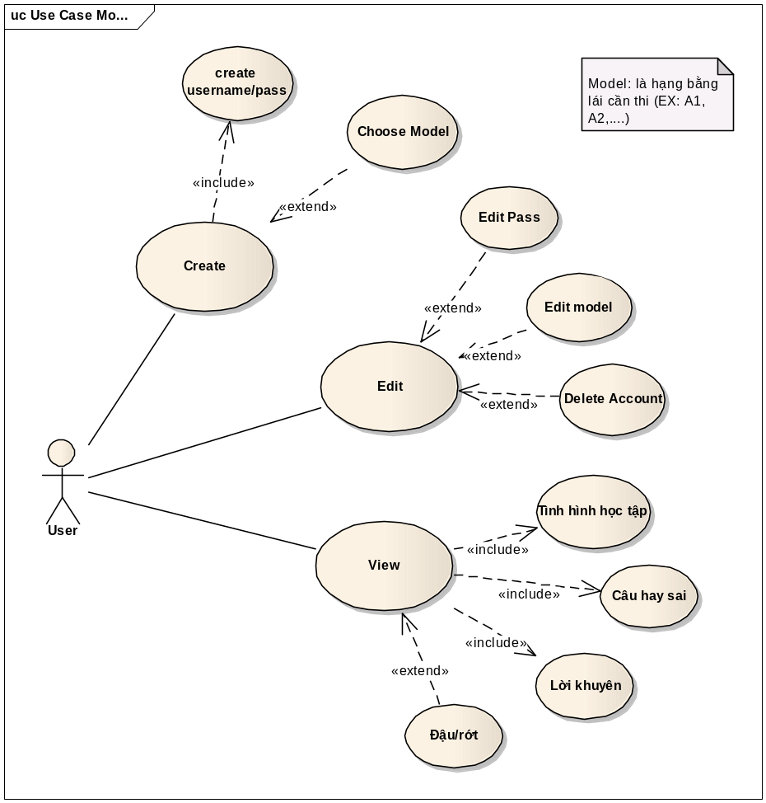

Học và luyện thi

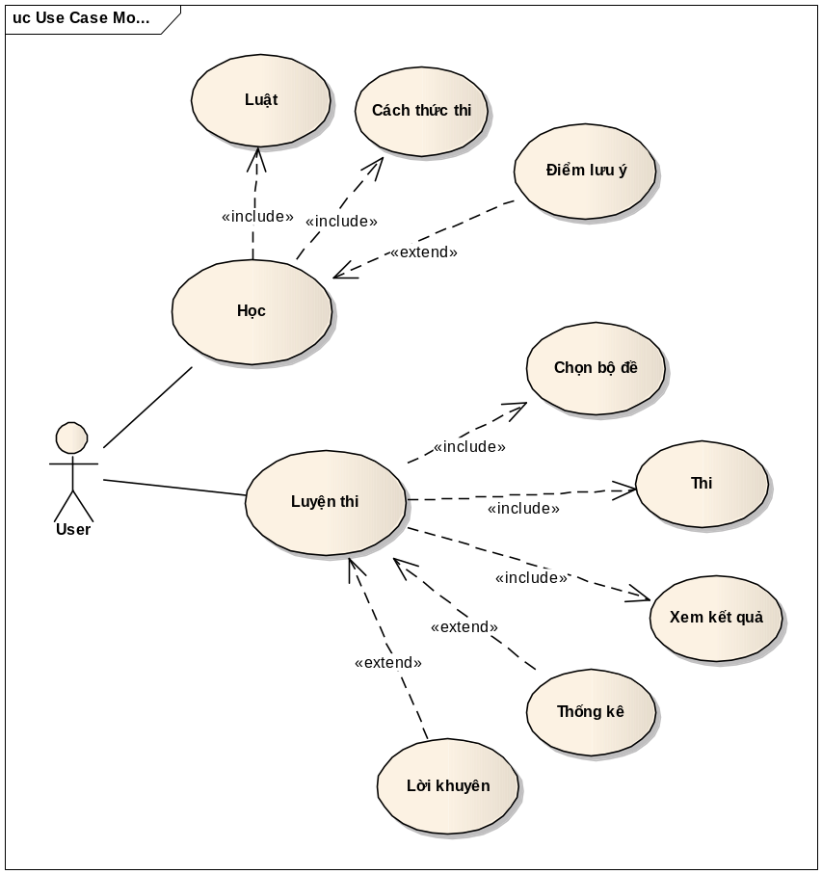

Tổ chức thi bằng lái xe trực tuyến
Góp sáng kiến

Functional Requirements

Tính năng tạo và chỉnh sửa Account

Use case Tạo account (MBK_UC_1.1)
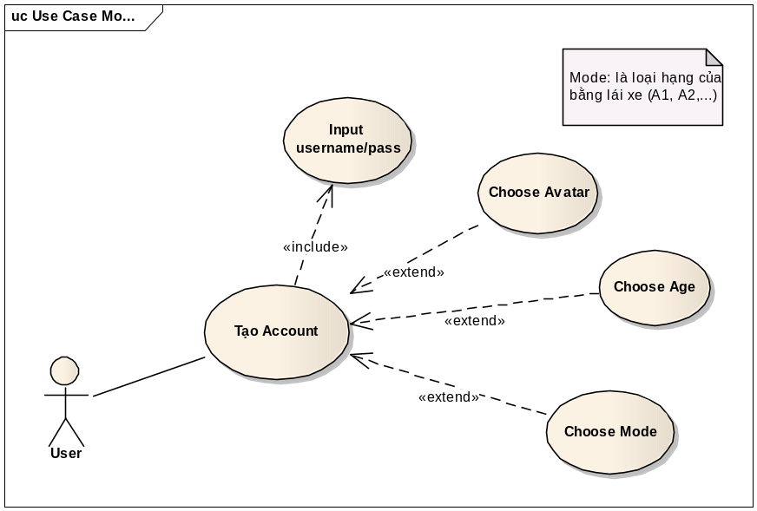
Use Case ID | MBK_UC_1.1
Name | Tạo account
Goal | Tạo account cho 1 user.
Actors | User
Include | Input username/pass
Extended | Choose avatar  Choose age  Choose mode
Pre-conditions | - Chưa account nào được tạo hay được chọn.  - Có ít nhất một bộ cơ sở dữ liệu (của một loại bằng lái xe) lưu trong SD Card.
Post-conditions | - Một Account được tạo và lưu trong SQLite.
Main Flow | - Khởi động chương trình mCarTest
Main Flow | - Khởi động chương trình mCarTest | - Load database để hiện thị loại bằng lái xe hiện có trong chương trình  - Hiển thị giao diện tạo account
Main Flow | - Điền vào username và password
Main Flow | - Chọn avartar là hình ảnh trong máy hoặc SD Card.  - Chọn loại bằng lái xe định thi  - Điền vào tuổi của user | - Kiểm tra tuổi của user có được phép thi bằng lái xe được chọn hay không?Đưa ra khuyến nghị.
Main Flow | - Click nút tạo account | - Tạo account trong SQLite
Exceptions | 2.A: Nếu không có database thì chương trình báo hiệu và yêu cầu người dùng download, hoặc copy database vào thư mục.  5.A: Nếu không chọn thì sẽ được chỉ định hình mặc định.  6.A: Nếu không chọn thì mặc định bản bằng lái xe hiện hành.  7.A: Nếu không điền tuổi của user, báo hiệu và yêu cầu nhập tuổi.  8.A: Nếu tuổi nhỏ hơn quy định thì báo hiệu và đưa ra khuyến nghị không được phép tạo user, đồng thời thoát chương trình.
Open Issues | N/A

Use case Backup Contact to Server (MBK_UC_1.2)
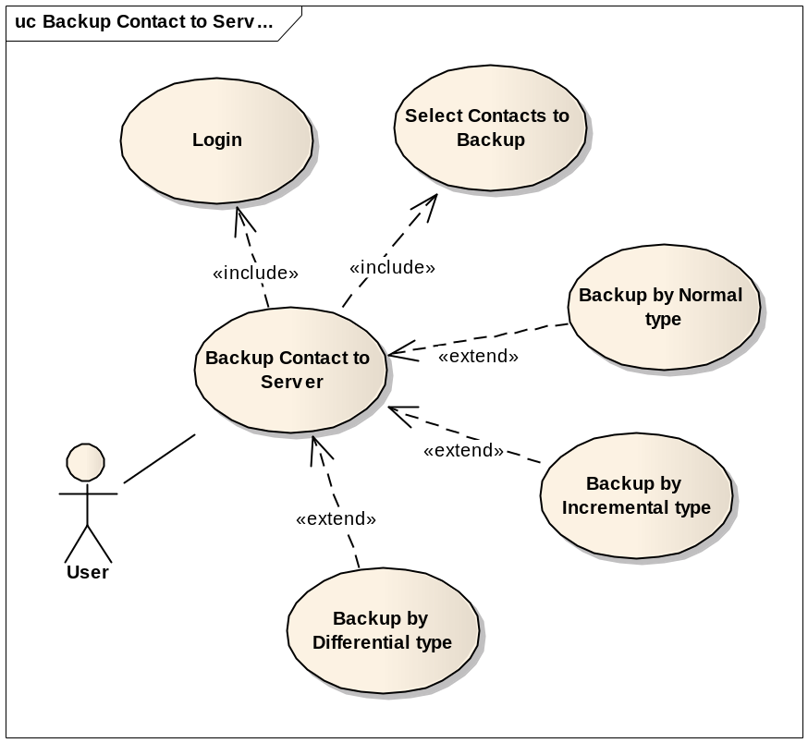

Use Case ID | MBK_UC_1.2
Name | Backup Contact to Server
Goal | Backup all or some contacts data and save on a server.
Actors | User
Include | Select contacts to backup  Login
Extended | Backup by normal type  Backup by incremental type  Backup by differential type
Pre-conditions | - All or some contacts are selected.  - SD card has enough memory to save file.  - There is internet connection  - Login with an registered account
Post-conditions | - A new backup version will be created on server
Main Flow | - Select Backup Contact to Server function
Main Flow | - Select Backup Contact to Server function | - Display an edit-text to enter descriptions of the backup version.
Main Flow | - Enter descriptions
Main Flow |  | - Connect to server, Display processes, remaining time.  - Read data of selected contacts and create a file to upload to server.  - Upload data file to server.  - Show the finish dialog.
Main Flow | - Confirm the finish dialog
Exceptions | 1.A: If user is not currently logged-in, show log-in form.  4.A: If internet connection is failed, remind user to get an internet connection.
Open Issues | N/A

Use case Backup Contact to Email (MBK_UC_1.3)
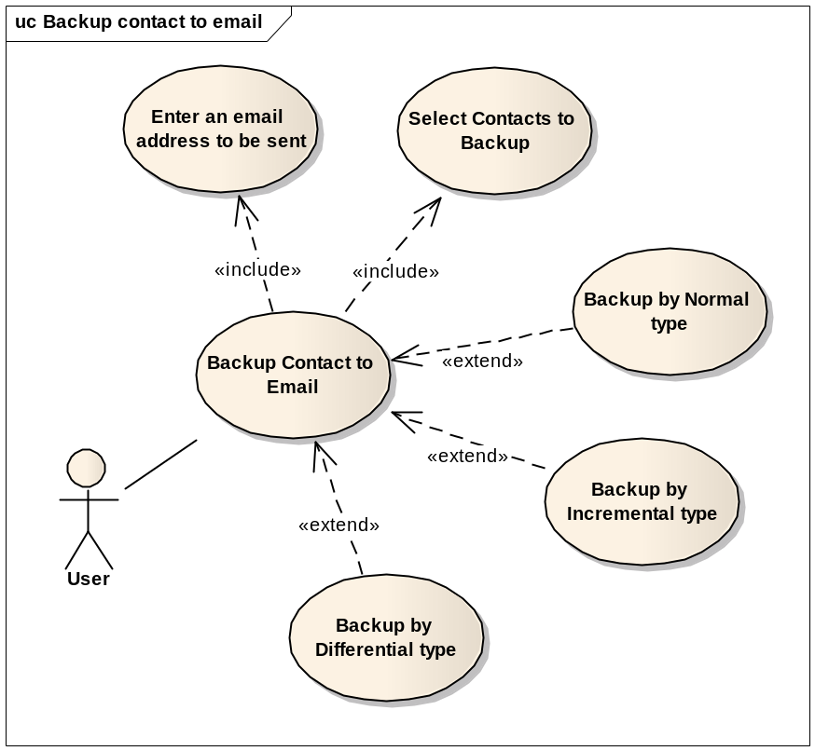

Use Case ID | MBK_UC_1.3
Name | Backup Contact to Email
Goal | Backup all or some contacts and send to an email account.
Actors | User
Include | Select contacts to backup  Enter an email account to be sent
Extended | Backup by normal type  Backup by incremental type  Backup by differential type
Pre-conditions | - All or some contacts are selected.  - SD card has enough memory to save file.  - There is internet connection  - Enter an email address to be sent
Post-conditions | A backup file will be sent to an email address
Main Flow | - Select Backup Contact to Server function
Main Flow | - Select Backup Contact to Server function | - Display an edit-text to enter descriptions of the backup version.
Main Flow | - Enter descriptions
Main Flow |  | - Display processes, remaining time.  - Read selected contact data and create a backup file  - Attach backup file and send to an email address.  - Show the finish dialog.
Main Flow | - Confirm the finish dialog
Exceptions | 4.A1: If internet connection is failed, remind user to get an internet connection.  4.A2. If email account has not been entered in the Settings yet, show the Settings.
Open Issues | N/A

Restore Contact (MBK_UC_1.4)
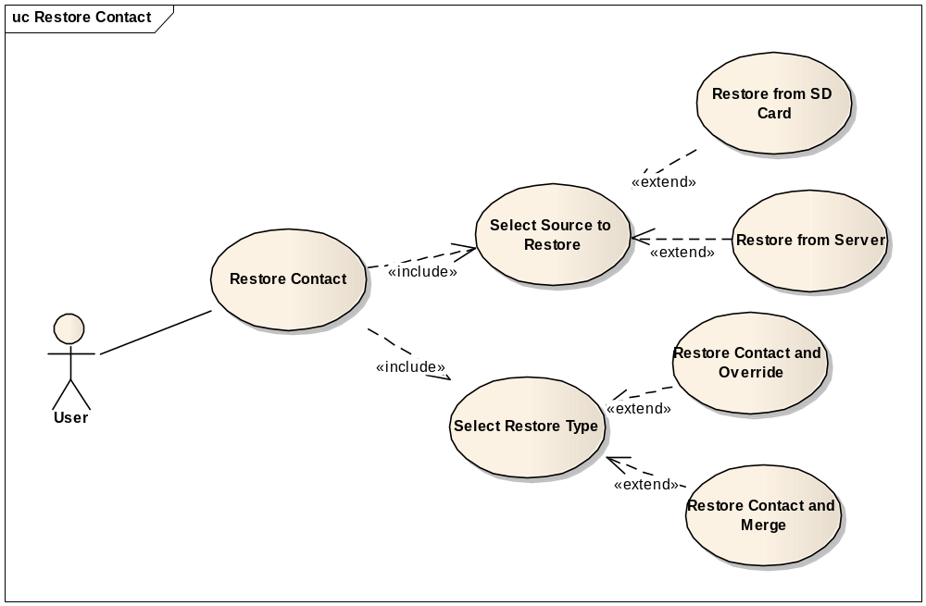
Use Case ID | MBK_UC_1.4
Name | Restore Contact
Goal | Restore Contact from SD card or server
Actors | User
Include | Select source to restore  Select restore type
Extended | N/A
Pre-conditions | - The backup version is available  - There is internet connection if restore from server.
Post-conditions | Contact data on user’s phone will be restored
Main Flow | - Select Restore Contact function
Main Flow | - Select Restore Contact function | - Display select backup source options
Main Flow | - Select backup source
Main Flow |  | - Display backup versions
Main Flow | - Select a version
Main Flow |  | - Display select restore method options
Main Flow | - Select restore method
Main Flow |  | - Run the selected restore function.  - Show processes, time remaining.  - Show the finish dialog
Main Flow | - Confirm the finish dialog
Exceptions | 2.A: If server source is selected, check the internet connection.  4.A: If there are no backup versions available, end the use-case.  6.A: If override method is selected, the old Contact data will be deleted.  8.A1: If server source is selected, connect to the server, down load backup file and restore to the phone.  8.A2: If SD card source is selected, read the backup file from SD card and restore to the phone
Open Issues | N/A

Schedule Contact Backup (MBK_UC_1.5)
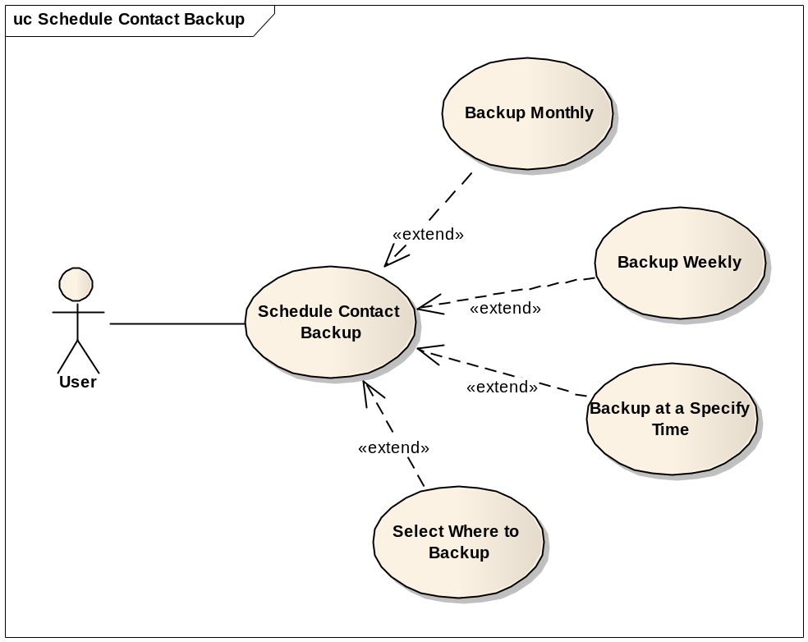

Use Case ID | MBK_UC_1.5
Name | Schedule Contact Backup
Goal | Schedule what time the Contact data will be automatically backed up.
Actors | User
Include | N/A
Extended | Backup monthly  Backup weekly  Backup at a specify time  Choose where to store
Pre-conditions | N/A
Post-conditions | Application will run the backup Contact data function automatically at the scheduled time
Main Flow | - Select the Schedule Contact Backup function
Main Flow | - Select the Schedule Contact Backup function | - Display the Schedule form
Main Flow | - Select time to backup automatically  - Select where to backup to  - Press “save settings” button.
Main Flow |  | - Save the schedule.
Exceptions | 4.A: If “backup to server” is selected, ensure that the phone has an internet connection.
Open Issues | N/A

Feature Backup and Restore Images

Use case Display all images (MBK_UC_2.1)
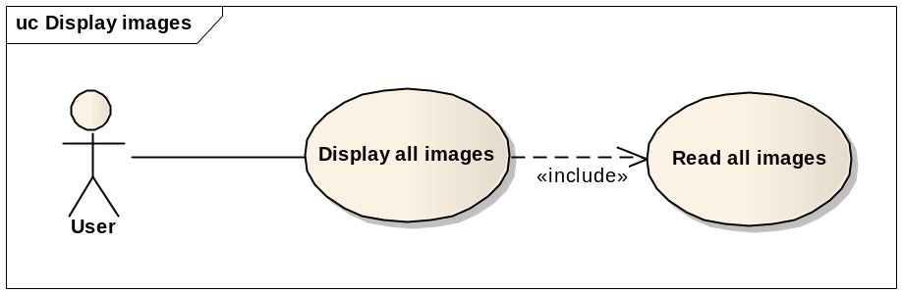
Use Case ID | MBK_UC_2.1
Name | Display all images
Goal | Display all images on the phone
Actors | User
Include | Read all images
Extended
Pre-conditions | Backup images function is selected
Post-conditions | Display all images on the phone to a gridview
Main Flow | - Select Backup Images function
Main Flow | - Select Backup Images function | - Display three options: display images, backup and restore images
Main Flow | - Choose display images
Main Flow |  | - Display progress bar for loading images.  - Read and display images.
Exceptions | 5.A1: If there is no images on the phone, show “emty image” message  5.A:2 If there are so much images, list images by catalog.
Open Issues | N/A

Use case Zip images (MBK_UC_2.2)

Use Case ID | MBK_UC_2.2
Name | Zip images
Goal | Zip all images to a zip file
Actors | User
Include | N/A
Extended | N/A
Pre-conditions | SD card has enough memory
Post-conditions | A zip file to archive all images will be created
Main Flow | - Select Backup Images function
Main Flow | - Select Backup Images function | - Display three options: display images, backup and restore images.
Main Flow | - Choose Backup function
Main Flow |  | - Show progress bar  - Read all images  - Check the sd card memory  - Zip all images to a zip file  - Show finished dialog
Exceptions | 6.A: If sd card does not have enough memory, warning user to get more space.
Open Issues | N/A

Use case Backup images to SD card (MBK_UC_2.3)
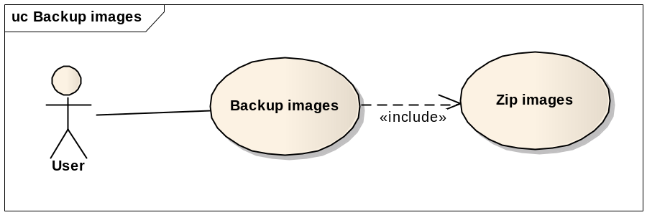

Use Case ID | MBK_UC_2.3
Name | Backup Images to SD card
Goal | Save zipped file to SD card
Actors | User
Include | Zip images
Extended | N/A
Pre-conditions | Finished zipping images successfully.
Post-conditions | Save zip file to SD card
Main Flow | - Select Backup Images function
Main Flow | - Select Backup Images function | - Display three options: display images, backup and restore images.
Main Flow | - Choose Backup function
Main Flow |  | - Show progress bar  - Check the sd card memory  - Save zip file to SD card  - Show finished dialog
Main Flow | - Confirm the finish dialog
Exceptions | 5.A. If sd card does not have enough memory, warning user to get more space.
Open Issues | N/A

Restore Images (MBK_UC_2.4)
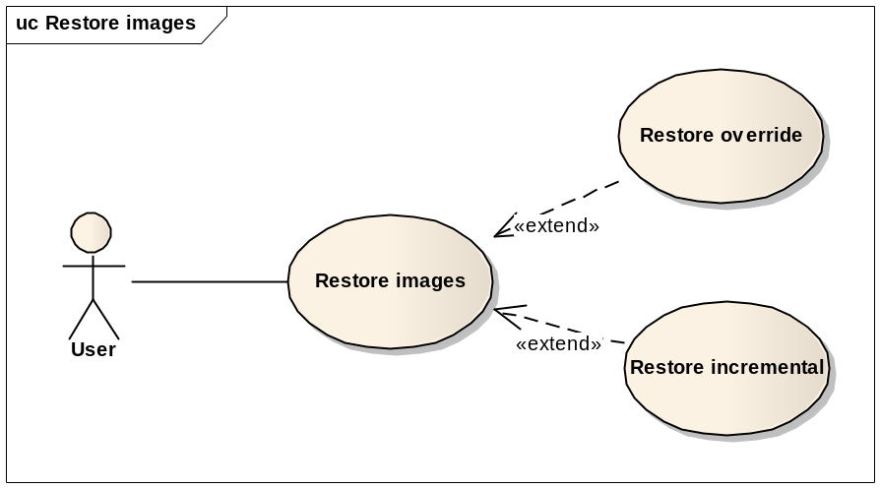
Use Case ID | MBK_UC_2.4
Name | Restore Images
Goal | Restore all images from zip file
Actors | User
Include | N/A
Extended | - Restore override  - Restore incremental
Pre-conditions | - A zip file is backed up on sd card  - SD card has enough memory to restore images
Post-conditions | Images will be restore to the phone
Main Flow | - Select Backup Images function
Main Flow | - Select Backup Images function | - Display three options: display images, backup and restore images.
Main Flow | - Choose Restore function
Main Flow |  | - Get all versions (zip files on sd card)
Main Flow | - Select a version
Main Flow |  | - Show progress bar  - Check the sd card memory  - Unzip and restore all images to the phone  - Show finished dialog
Exceptions | 7.A. If sd card does not have enough memory, warning user to get more space.
Open Issues | N/A

Feature Backup and Restore SMS

Use case Backup SMS to SD Card (MBK_UC_3.1)
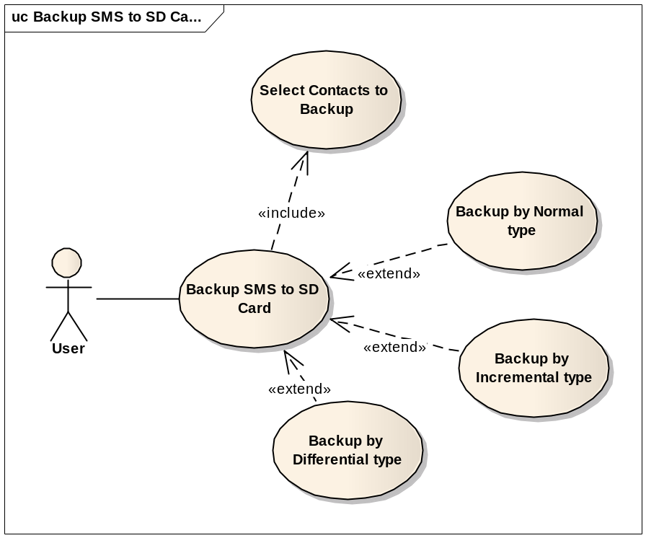
Use Case ID | MBK_UC_3.1
Name | Backup SMS to SD Card
Goal | Backup all or some SMSs which is selected and save to SD Card as a file
Actors | User
Include | Select SMSs to backup
Extended | Backup by Normal type  Backup by Incremental type  Backup by Differential type
Pre-conditions | - All or some SMSs are selected.  - SD card has enough memory to save file.
Post-conditions | - A backup file will be stored in SD card.
Main Flow | - Select Backup SMS to SD Card function
Main Flow | - Select Backup SMS to SD Card function | - Display edit-texts to enter file name and descriptions.
Main Flow | - Enter file name
Main Flow |  | - Display processes, remaining time.  - Read SMSs and create a file to save them all.  - Write data file to SD card.  - Show the finish dialog.
Main Flow | - Confirm the finish dialog
Exceptions | 4.A: If SD card is not enough memory, stop all processes and remind user to delete files to get more space.  6.A: If it’s impossible to write file to SD card, remind user to get permissions from settings.
Open Issues | N/A

Use case Backup SMS to Server (MBK_UC_3.2)
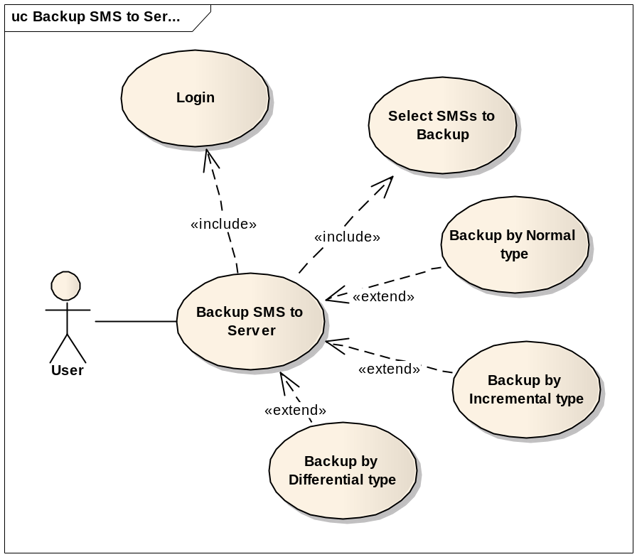

Use Case ID | MBK_UC_3.2
Name | Backup SMS to Server
Goal | Backup all or some SMSs data and save on a server.
Actors | User
Include | Select SMSs to backup  Login
Extended | Backup by normal type  Backup by incremental type  Backup by differential type
Pre-conditions | - All or some SMSs are selected.  - SD card has enough memory to save file.  - There is internet connection  - Login with an registered account
Post-conditions | - A new backup version will be created on server
Main Flow | - Select Backup SMS to Server function
Main Flow | - Select Backup SMS to Server function | - Display an edit-text to enter descriptions of the backup version.
Main Flow | - Enter descriptions
Main Flow |  | - Connect to server, Display processes, remaining time.  - Read data of selected SMSs and create a file to upload to server.  - Upload data file to server.  - Show the finish dialog.
Main Flow | - Confirm the finish dialog
Exceptions | 1.A: If user is not currently logged-in, show log-in form.  4.A: If internet connection is failed, remind user to get an internet connection.
Open Issues | N/A

Use case Backup SMS to Email (MBK_UC_3.3)
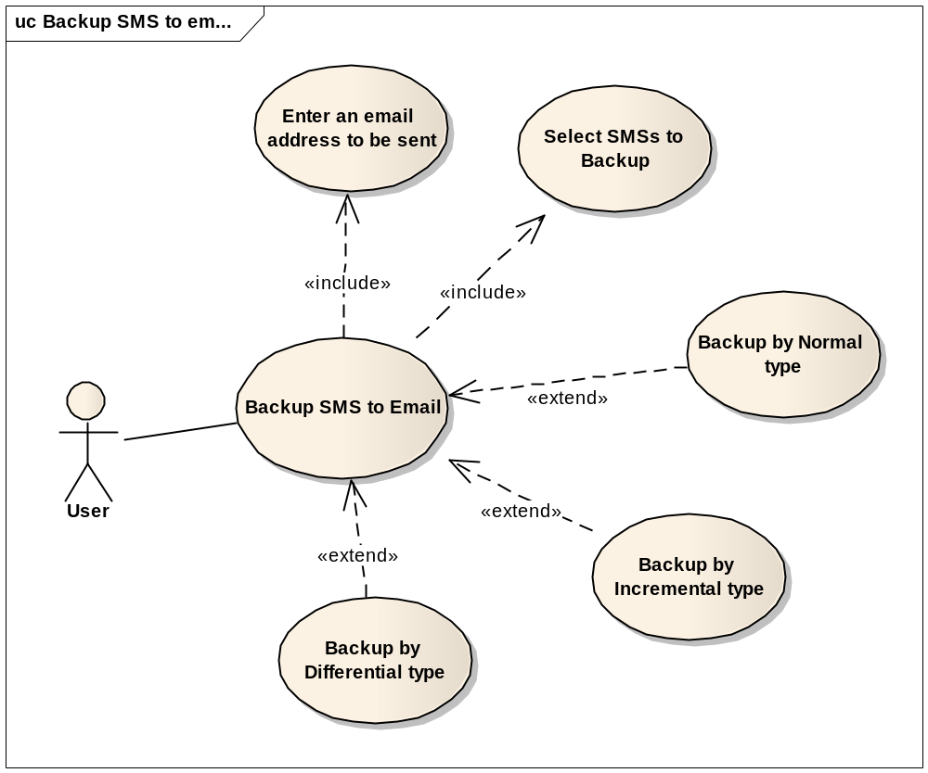

Use Case ID | MBK_UC_3.3
Name | Backup SMS to Email
Goal | Backup all or some SMSs and send to an email account.
Actors | User
Include | Select SMSs to backup  Enter an email account to be sent
Extended | Backup by normal type  Backup by incremental type  Backup by differential type
Pre-conditions | - All or some SMSs are selected.  - SD card has enough memory to save file.  - There is an internet connection  - Enter an email address to be sent
Post-conditions | A backup file will be sent to an email address
Main Flow | - Select Backup SMS to Server function
Main Flow | - Select Backup SMS to Server function | - Display an edit-text to enter descriptions of the backup version.
Main Flow | - Enter descriptions
Main Flow |  | - Display processes, remaining time.  - Read selected SMS data and create a backup file  - Attach backup file and send to an email address.  - Show the finish dialog.
Main Flow | - Confirm the finish dialog
Exceptions | 4.A1: If internet connection is failed, remind user to get an internet connection.  4.A2. If email account has not been entered in the Settings yet, show the Settings.
Open Issues | N/A

Restore SMS (MBK_UC_3.4)
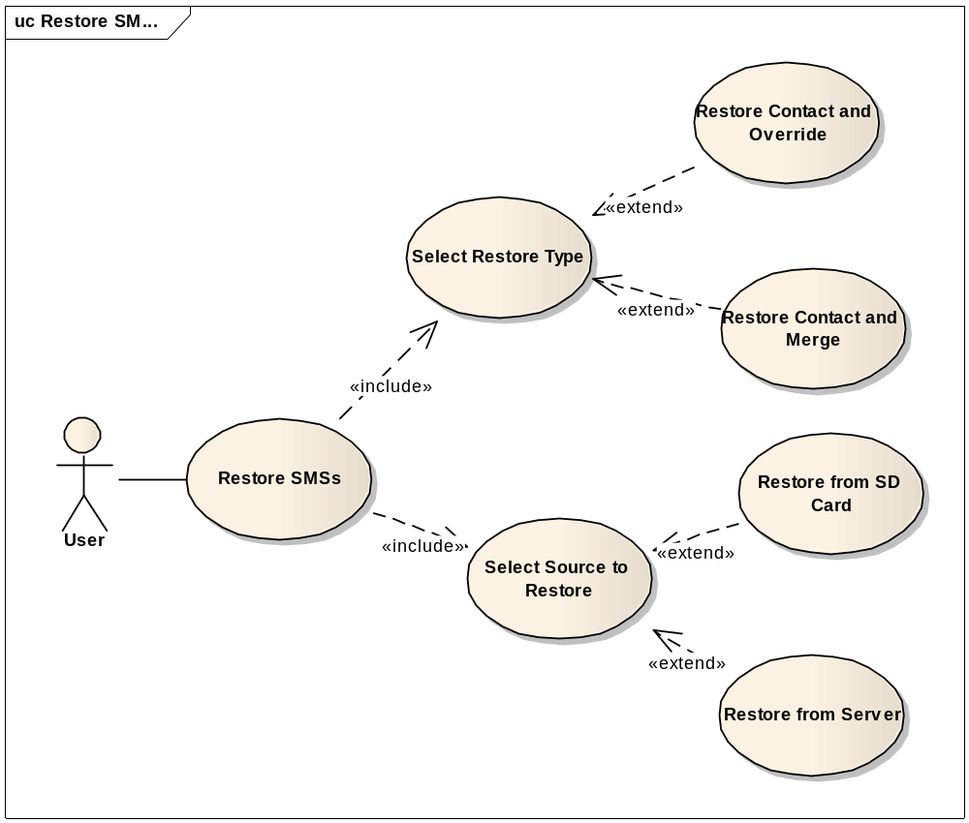
Use Case ID | MBK_UC_3.4
Name | Restore SMS
Goal | Restore SMS from SD card or server
Actors | User
Include | Select source to restore  Select restore type
Extended | N/A
Pre-conditions | - The backup version is available  - There is internet connection if restore from server.
Post-conditions | SMS data on user’s phone will be restored
Main Flow | - Select Restore SMS function
Main Flow | - Select Restore SMS function | - Display select backup source options
Main Flow | - Select backup source
Main Flow |  | - Display backup versions
Main Flow | - Select a version
Main Flow |  | - Display select restore method options
Main Flow | - Select restore method
Main Flow |  | - Run the selected restore function.  - Show processes, time remaining.  - Show the finish dialog
Main Flow | - Confirm the finish dialog
Exceptions | 2.A: If server source is selected, check the internet connection.  4.A: If there are no backup versions available, end the use-case.  6.A: If override method is selected, the old SMS data will be deleted.  8.A1: If server source is selected, connect to the server, down load backup file and restore to the phone.  8.A2: If SD card source is selected, read the backup file from SD card and restore to the phone
Open Issues | N/A

Schedule SMS Backup (MBK_UC_3.5)
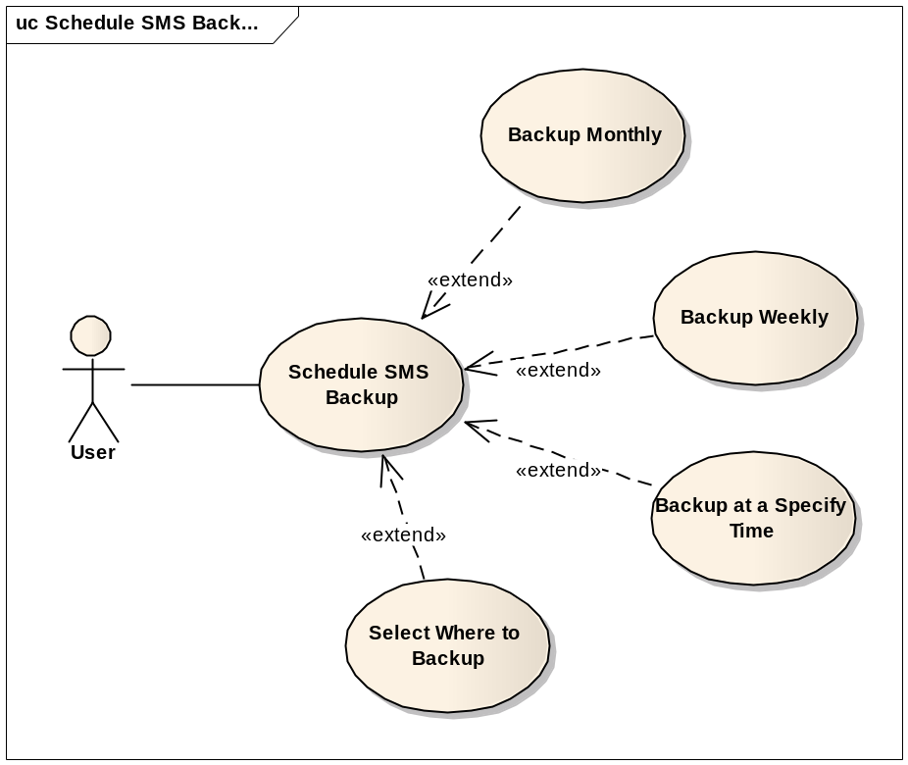

Use Case ID | MBK_UC_3.5
Name | Schedule SMS Backup
Goal | Schedule what time the SMS data will be automatically backed up.
Actors | User
Include | N/A
Extended | Backup monthly  Backup weekly  Backup at a specify time  Choose where to store
Pre-conditions | N/A
Post-conditions | Application will run the backup SMS data function automatically at the scheduled time
Main Flow | - Select the Schedule SMS Backup function
Main Flow | - Select the Schedule SMS Backup function | - Display the Schedule form
Main Flow | - Select time to backup automatically  - Select where to backup to  - Press “save settings” button.
Main Flow |  | - Save the schedule.
Exceptions | 4.A: If “backup to server” is selected, ensure that the phone has an internet connection.
Open Issues | N/A

Feature Backup and Restore Use BackupAgent

Use case Backup data to Cloud (MBK_UC_4.1)

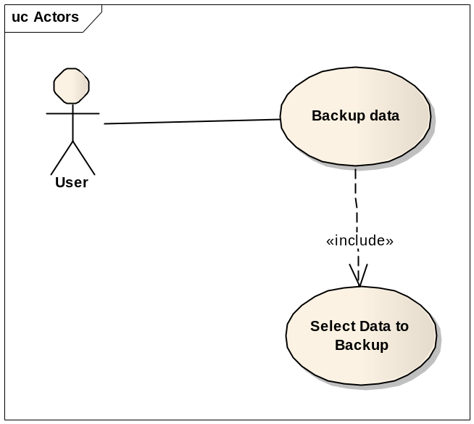

Use Case ID | MBK_UC_4.1
Name | Backup data to Cloud
Goal | Backup all data and save to Cloud
Actors | User
Include | Select Application
Extended | N/A
Pre-conditions | - Data which you want to backup is selected  - Has an internet connection for saving to Cloud
Post-conditions | A backup file will be stored on cloud
Main Flow | - Select Backup data to cloud function
Main Flow | - Select Backup data to cloud function | - Display edit-texts to enter file name and descriptions.
Main Flow | - Enter file name
Main Flow |  | - Display processes, remaining time.  - Read all Memo data and create a file to save them all.  - Save data file to cloud  - Show the finish dialog.
Main Flow | - Confirm the finish dialog
Exceptions | 4.A: If Internet is disconnected, stop all processes and remind user to delete files to get more space..
Open Issues | N/A

Restore use BackupAgent (MBK_UC_4.2)

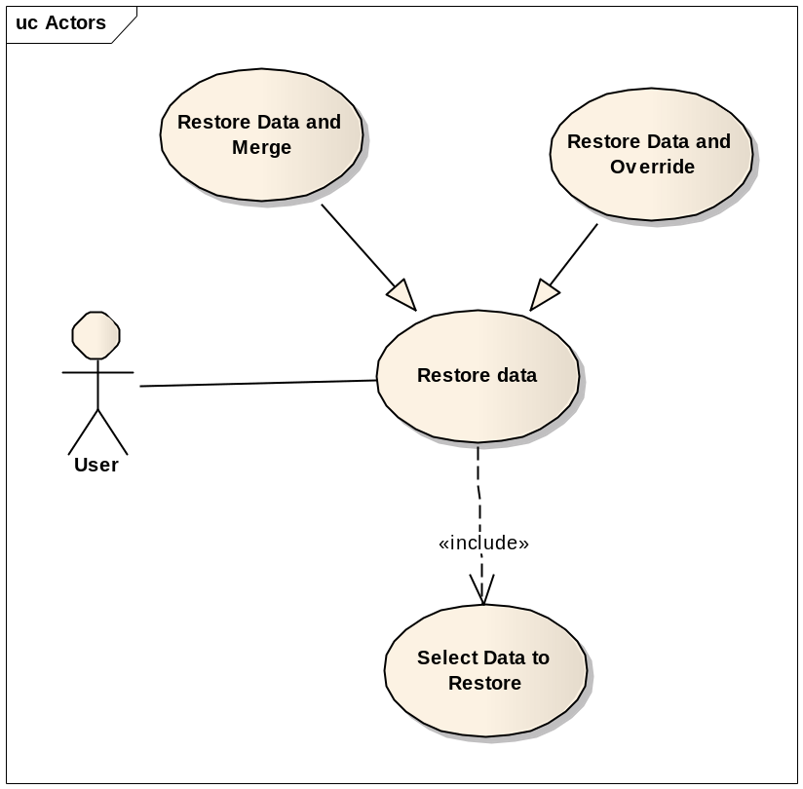

Use Case ID | MBK_UC_4.2
Name | Restore use BackupAgent
Goal | Restore Data from clound
Actors | User
Include | Select Application
Extended | N/A
Pre-conditions | - Data is selected  - Has an internet connection for restoring from Cloud
Post-conditions | Memo data on user’s phone will be restored
Main Flow | - Select Restore use BackupAgent function
Main Flow | - Select Restore use BackupAgent function | - Display select backup source options
Main Flow | - Select backup source
Main Flow |  | - Display backup versions
Main Flow |  | - Display select restore method options
Main Flow |  | - Run the selected restore function.  - Show processes, time remaining.  - Show the finish dialog
Main Flow | - Confirm the finish dialog
Exceptions | 2.A: If server source is selected, check the internet connection.  4.A: If there are no backup versions available, end the use-case.  6.A: If override method is selected, the old data will be deleted.  8.A1: If server source is selected, connect to the server, down load backup file and restore to the phone.
Open Issues | N/A

Schedule Backup using Backup Agent (MBK_UC_4.3)

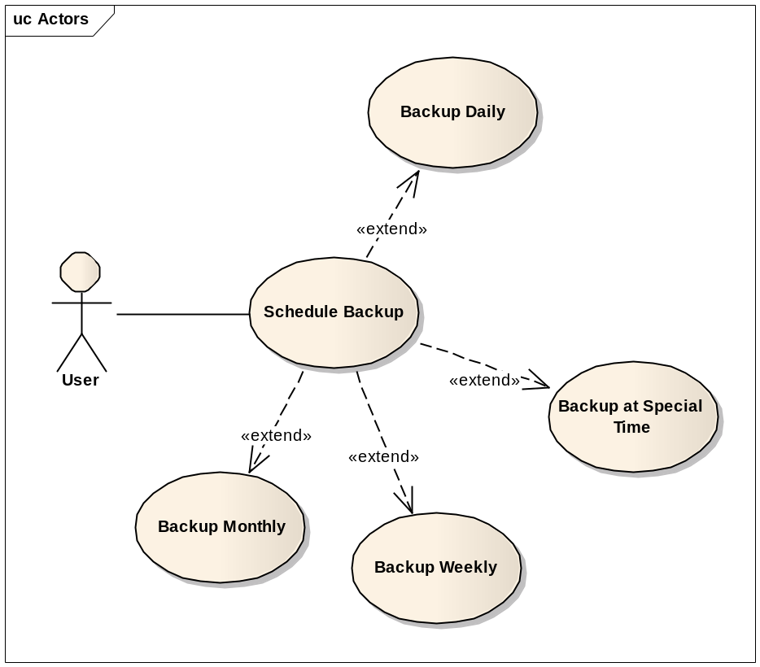

Use Case ID | MBK_UC_4.3
Name | Schedule Backup
Goal | Schedule what time the data will be automatically backed up.
Actors | User
Include | N/A
Extended | Backup monthly  Backup weekly  Backup at a specify time  Choose where to store
Pre-conditions | N/A
Post-conditions | Application will run the backup Memo data function automatically at the scheduled time
Main Flow | - Select the Schedule Memo Backup function
Main Flow | - Select the Schedule Memo Backup function | - Display the Schedule form
Main Flow | - Select time to backup automatically  - Select where to backup to  - Press “save settings” button.
Main Flow |  | - Save the schedule.
Exceptions | 4.A: If “backup to server” is selected, ensure that the phone has an internet connection.

---------- End of Document ----------

